Flight Aid

https://github.com/hdbrazier/SDEV140

Validation Testing

The first window accepts user input for employee number and time of call request.

Validation is conducted to ensure all inputs are integers and will display an error if they are not valid. If entry inputs are correct, a message is displayed confirming the transfer request has been initiated.

Errors tested include leaving entry-box blank and inputting an alpha character. See figure 1.1 and 1.2 below.

A confirmation window pops up when all is correct. See figure 1.3

The second window accepts patient details, utilizing dropdown lists and entry boxes for user input. Validation is conducted upon clicking the Submit button, in the event any detail has been missed, an error message will be displayed asking the user to correct the entry.

Patient name error message displays if there are any non-alphabetic characters entered or entry is blank. See figure 2.1

Patient weight error message displays if there are any non-numeric characters entered or entry is blank. See figure 2.2

Patient age error message displays if there are any non-numeric characters entered or entry is blank. See figure 2.3

Blank entry. See figure 2.4

I would have liked more time to enable and disable buttons to ensure accurate order is followed.

Good test data working, see figure 3.1. Shows the Submit Form with all details and a copy of the data written into a file for record keeping. Figure 3.2 shows the Transfer Log file with 3 sets of accurate data. I have also uploaded a video of errors and a video of correct performance to GitHub.

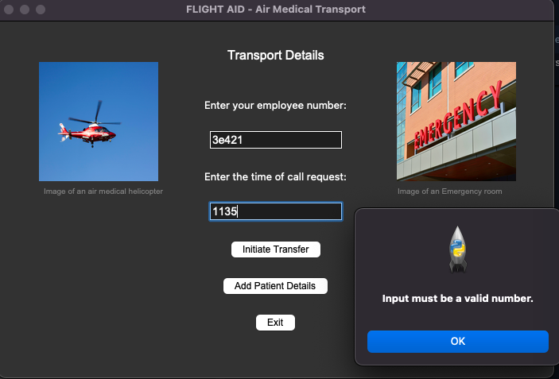

Figure 1.1

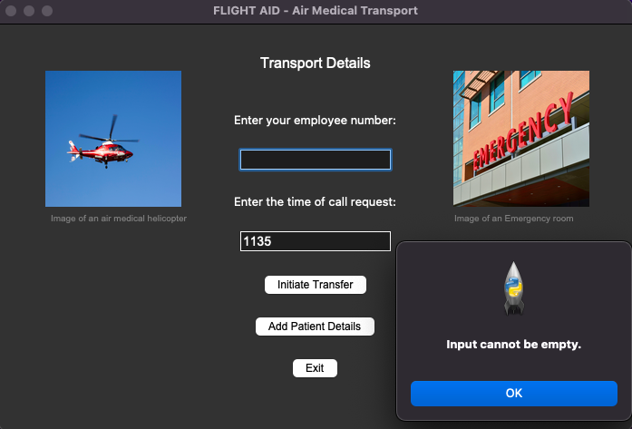

Figure 1.2

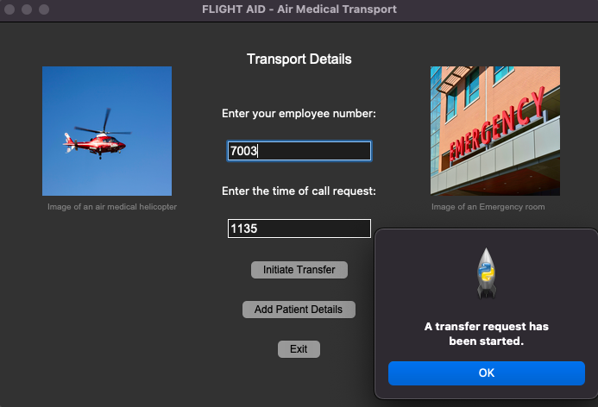

Figure 1.3

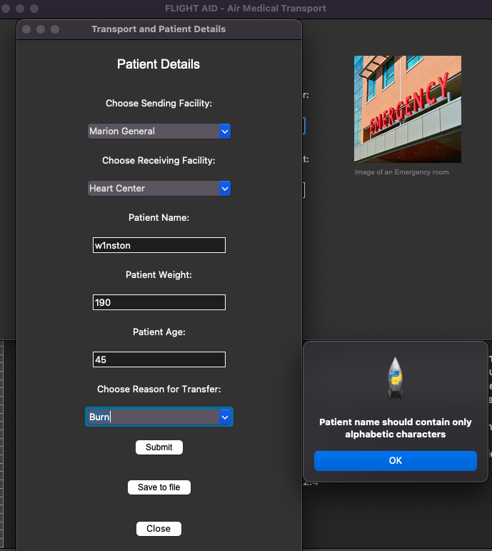

Figure 2.1

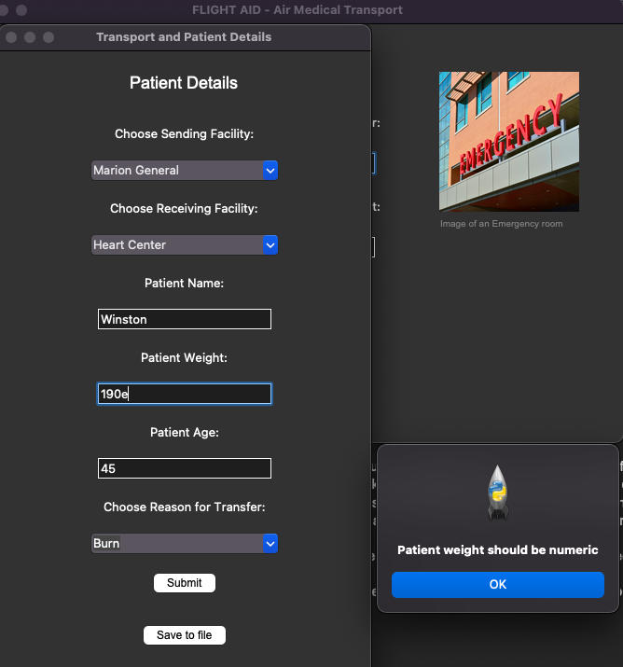

Figure 2.2

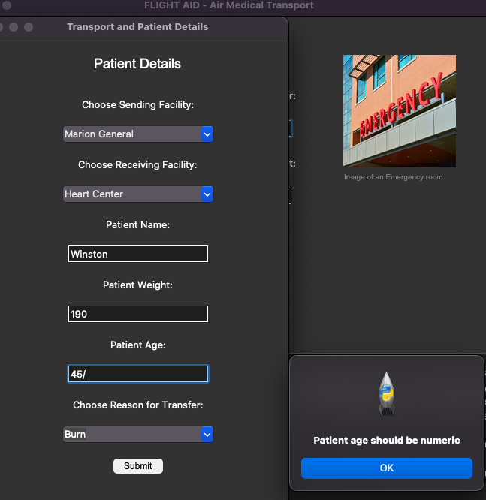

Figure 2.3

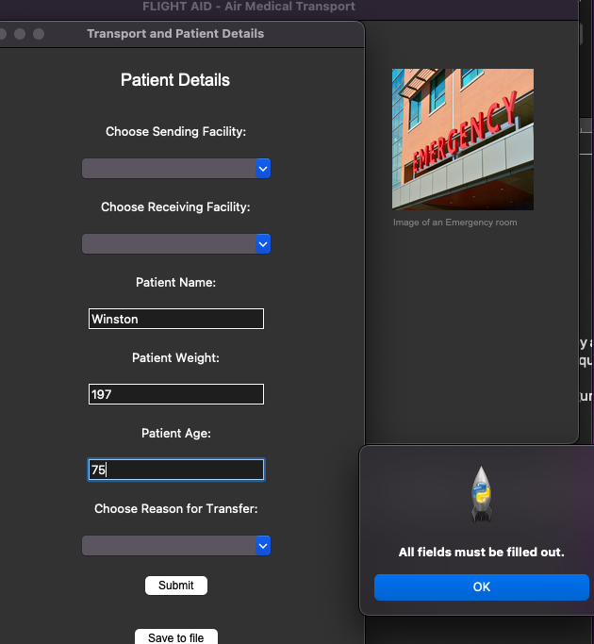

Figure 2.4

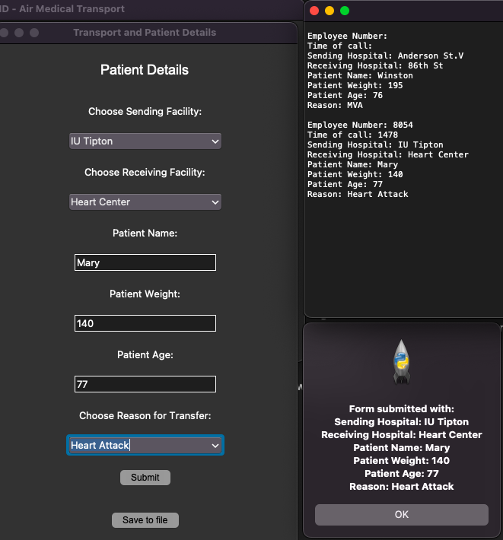

Figure 3.1

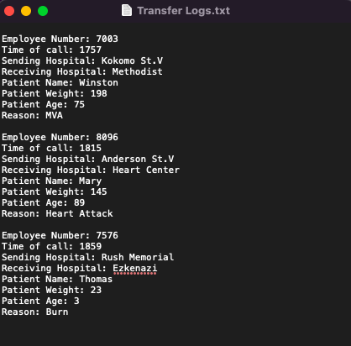

Figure 3.2